Current Market View – January 2026

Investment Markets
Global Markets
January is traditionally a good month for US (and global) share markets as it is bonus month for most US middle-class workers, and most politicians and portfolio managers are on leave. Usually not much happens of note to upset financial markets. In Australia the holiday period is longer than elsewhere, and the highlights usually end up being the cricket, tennis, and perhaps the odd bushfire.
But there was plenty to rattle markets this January. Trump escalating his ‘excellent adventure’ in whole new directions – including abducting the President of Venezuela, seizing its oil, and appointing himself President of Venezuela. He also appointed himself head of the body to turn Gaza into a grand casino project, and he threatened to seize Greenland from Denmark. Trump also announced more tariff hikes and backflips, and stepped up his war on the ‘enemy within’ on the streets of US cities, killing more citizens.
Much happened in the rest of the world of course, but nothing affects global markets (including Australia) as much as US events because the US still has the largest, deepest, most liquid capital markets in the world.

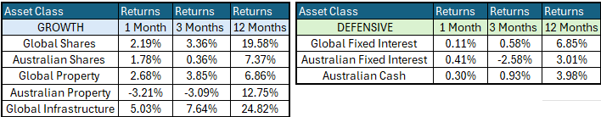

Global Share Markets
It was a good start to the year for global markets with most finishing the month in the positive. All global industry sector posted gains for the first time since October 2024. Best of the major markets included Japan (exporters like Toyota benefiting for lower yen), China (Alibaba & Baidu), Taiwan (TSMC) and South Korea (Samsung Electronics).
The US market was up a more modest 1.5% (but the S&P500 still managed to post four new all-time record highs for the month). Gainers were mainly fossil fuels, staples, healthcare, industrials, materials, but most financials were down. The overall US market was dragged down by a mixed tech sector (which is spread across three sectors tech, comms, and discretionaries). Gainers included Meta/Facebook, Alphabet/Google, Amazon, Intel, Nvidia, but there were falls in Apple, Microsoft, Broadcom, Adobe, Oracle, Tesla, and Netflix.

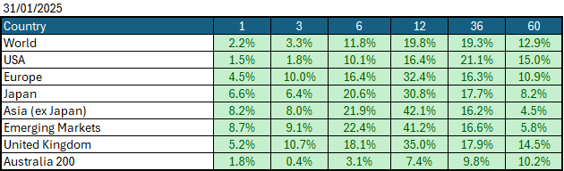
Data Source: AFM as of December 31 2025.

Global Bond Markets
Bond markets remain unconvinced by the tariff reprieve, believing that the outcome will ultimately lead to further inflation. The latest inflation data came in slightly softer than expected, while the market continued to price in a US interest rate cut in later in the year. Although the market is expecting cuts later this year, the bond market continues to worry about the volume of debt that will have to be rolled in the coming year.
Interest rate markets in the US and the UK eased over January 2026, with the 10-year Government bonds increasing to 4.2733%. UK 10-year Gilts were trading at 4.627% on January 31 2026.
Domestic Bond Markets
Treasury yields rose in Australia across all maturities as markets priced in rate hikes and sticky inflation. For Australia, the latest inflation prints for (year-on-year) December 2025 increased to 3.8%, which was a slight increase from 3.4% in November 2025. The RBA board is set to meet on the 2nd/3rd February 2026, where which has the market pricing in a rate hike of +25bps to 3.85%.
Investment Climate
US equities ended January 2026 on a positive note, beginning the year off on the right foot, lifted by the outlook for more Federal Reserve rate cuts and higher company profits. US profit reporting season for Q4 2025 has been mostly good so far. The US market may be over-priced based on underlying profits, but the share price gains of +16% in calendar 2025 were actually underpinned by matching +16% growth in corporate earnings per share for the year. The market is expensive, but no more so than it was a year ago.
Medium-term investors are encouraged by the anticipated gradual easing of interest rates; however, the unsettled nature of the share and bond markets clouds the short-term direction. Soft-landing expectations and economic recovery are still supported by the data, despite recent volatility.
The medium-term view remains positive for returns, as US Fed Chair Jerome Powell appears to have shifted his stance toward further US interest rate easing in 2026. At the January 2026 Meeting, the Fed held interest rates at3.75%, with the market anticipating one of two more interest rate cuts later this year.
Long-term investors are optimistic about a recovery period ahead. Global central banks continue to indicate a resolve to get inflation under control; however, economic data is showing signs of stabilisation despite elevated inflation, and every indication is that future monetary policy easing is possible in 2026.
The following commentary is based on month-end closing prices as of January 31 2026:
Global share markets were stronger over January, with Japan, China and South Korea outperforming the US and Australian markets, following the increase in macroeconomic news coming out of the USA. The AUD/USD strengthened from 0.6673 to 0.6963 (+4.3%).
The US Fed held monetary policy to the target range for the federal funds rate of 3.50%-3.75% when it met on the 27th/28th January 2026. Investors are gaining more confidence that the economy is headed for a soft landing despite the intermittent bouts of volatility. The next Fed meeting is on the 17th/18th March 2026.
The underlying short-term theme is "risk-on" for shares.
The situation in the Russia/Ukraine conflict remains unchanged; with the latest conflict between Israel and Gaza (Hamas) remaining unchanged as well.
Investor Focus
For Australia, investors focused on the following issues:
- Cost of living expenses and the impact on consumer spending.
- Commodity prices (post-China policy changes) and the impact on company profits.
- The level of interest rates and the delicate position of the RBA, given the global volatility in markets.
- US tariffs and the impact on Australia's exports (if any).
- Inflation (year-over-year) increased to 3.8% in December, with the next quarterly CPI being released on January 28, 2026.
- Government spending and the rising debt level.

Currency
The Australian Dollar closed stronger, AUD/USD 0.6963 at the end of January 2026, up from 0.6673. This was following the Fed keeping rates on hold during the month and the macroeconomic data in Australia pointing towards a rate hike in February.

Currency forecasters see the AUD/USD range between:
0.65 and 0.75 cents in the medium term and most likely to trade within the:
0.5500 to 0.7500 range in the longer term.

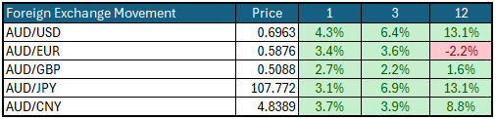

Australian Economy
Australia's latest GDP data for the third quarter of 2025 revealed an annual growth rate of 2.1%, which was up from 1.8% in the second quarter of 2025. Unemployment fell to 4.1% in January 2026. The year-over-year (Y-O-Y) inflation rate increased to 3.8% in December 2025, up from 3.4% in November 2025, which is now outside the Reserve Bank's targeted 2% to 3% inflation range and will likely lead to a rate hike in February.

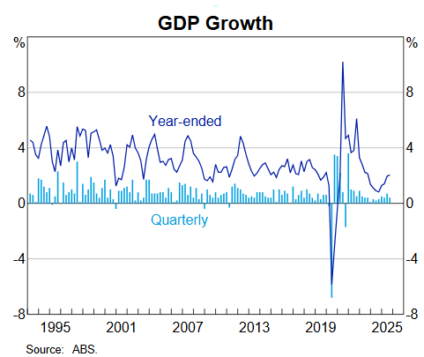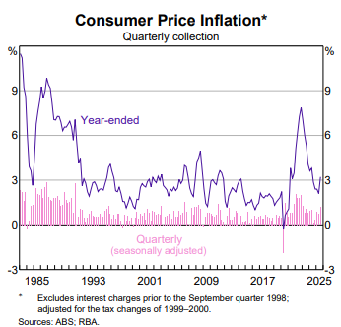

Current Market View

Domestic View
The overall investment view for shares is "risk-on" over the short term, "cautiously optimistic" over the medium term, and "long run" as corporate profits continue to grow quicker than inflation and the need to build out data centres to drive commodity prices over the short term.
The market is expecting no interest rate cuts with an interest rate hike on the 2nd/3rd of February 2026, due to a "hotter" inflation print in December that showed inflation is now outside the RBA's target range of 2-3%.

Global View
The global share market remains optimistic with ongoing support from the Fed, which is likely to cut interest rates once more in 2026. Inflation remains subdued as tariffs haven't impacted the economy fully. GDP remains strong in the US as AI infrastructure investment continues to boost spending across the country.

Where to From Here?
- Continued shift from rules-based order and win-win multilateral trade, to power-based order and win-lose trade deals. This shift started in the 2010s with US/Europe letting Putin take Crimea, and US/Japan letting China militarise the South-China Sea, but accelerated under Trump. Lower cross-border trade & investment, projects delayed, more reliance on subsidies, inflationary on-shoring of uneconomic industries.
- Sticky inflation - political pressure on central banks to keep rates low – populist pressure on governments to keep deficit spending. Tariffs + onshoring adding to costs/prices. Bond yields to drift up, risk of bond yield spike, or sudden need for rate hikes, unsettling/breaking share markets.
- Share markets continue tech/ai rally, supported by good profit growth for now. Shares everywhere are expensive but buoyed by loose monetary & fiscal policies, plus a near certainty that governments will throw money at any problem.
- Commodities rally gathering pace – rising demand soaking up over-supply, ai / data centre boom (industrial metals, energy, water, land), global re-armament – especially Europe, Japan, Canada. This should support ASX market, as long as banks avoid a local recession.
- De-dollarisation fears probably over-done, but is driving up gold, silver, but not bitcoin. US treasury yields not at risk for now.
- The current boom will end one day of course. All markets everywhere, including and especially Australia, are over-priced on fundamentals, not just US-big tech. However, each boom is different and the triggers for the inevitable bust are different each time.

This document is issued by Atlas Funds Management Pty Ltd. Atlas Funds Management Pty Ltd does not provide any general advice or personal advice regarding any potential investment in any financial products within the meaning of section 766B of the Corporations Act. No consideration has been made of any specific person's investment objectives, financial situation or needs. The provision of this presentation is not and should not be considered as a recommendation in relation to an investment in any entity or that an investment in any entity is a suitable investment for any specific person. Recipients should make their own enquiries and evaluations they consider appropriate to determine the suitability of any investment (including their investment objectives, financial situation, and particular needs) and should seek all necessary financial, legal, tax and investment advice. Atlas Funds Management Pty Ltd, it's directors and employees do not accept any liability for the results of any actions taken or not taken on the basis of information in this presentation, or for any negligent misstatements, errors or omissions. This presentation is not an advertisement and is not intended for public use or distribution. Past performance of a fund is no guarantee of its future performance.

